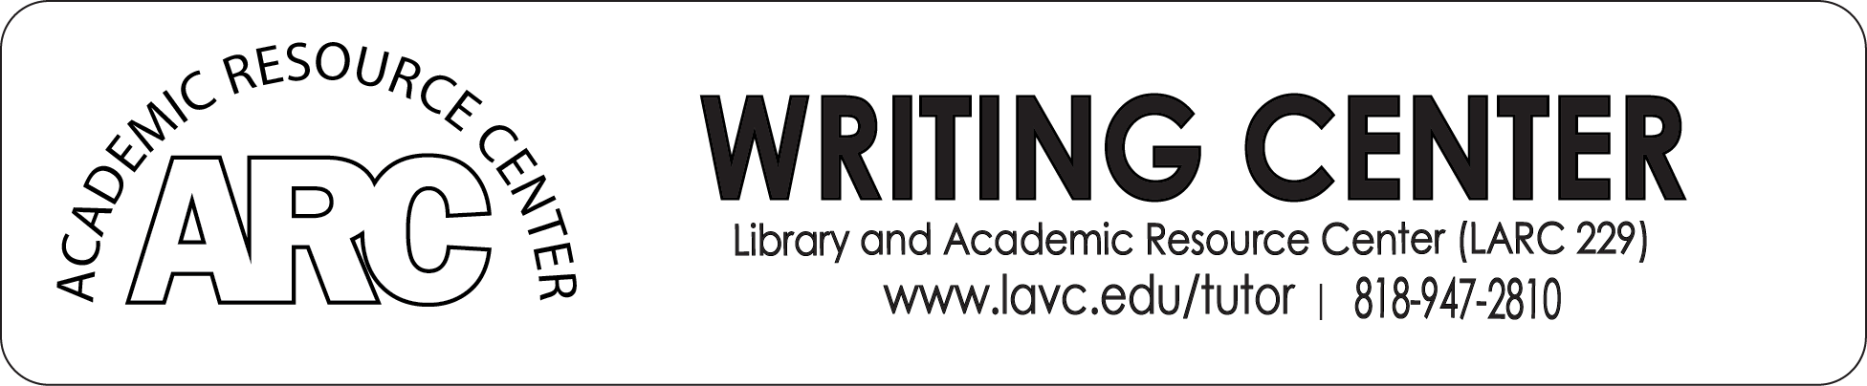

Handout on BASIC MLA FORMAT 8th EDITION

Modified by K. Yegoryan

MLA: Modern Language Association that decides:
- Format
- Citation

Formatting
• 12 font Times new Roman, double spaced, 1’ Margins in all sides
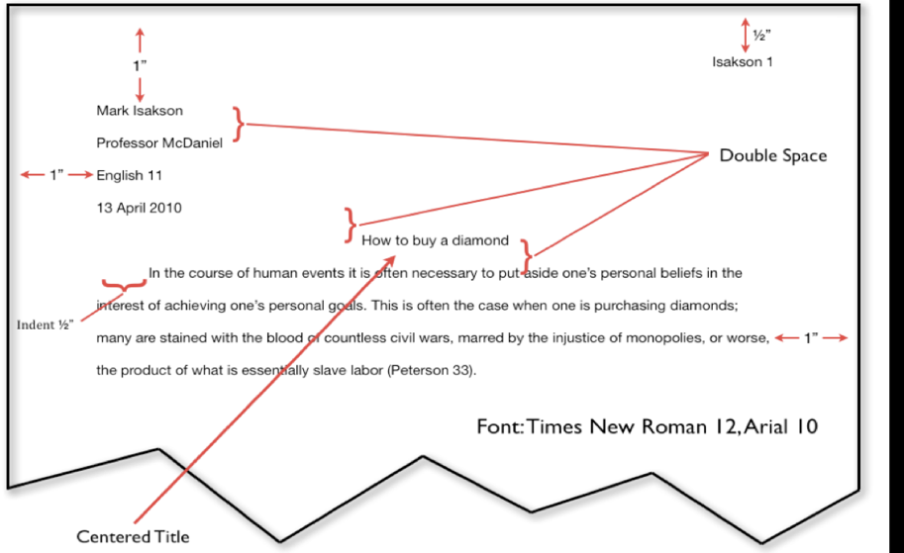
• Header: Your last name and page number
• Heading (only on the 1st page)

Citation:
- In-Text Citation (Quotes)
- Works Cited Page (Sources- places (articles, web sites, books) we got the quotes)

Where to look for Credible Sources?
- LAVC Library database
- Google Scholar
- The credible citations that were used in a (credible) source or in wiki they are in the END of the article or Wikipedia information
__________________________________________

In-Text Citation:
- Direct Quotes - “word by word” direct quote cannot be longer than 4 typed lines
- Indirect Quotes – the idea is from a source restated with your words

Introducing In-text Citations:

- By Signal words - According to Tom Smith the author of the article, “………..”
As Tom Smith, the author states “………….”

- Parenthetical - “…………..” (Smith).

Works Cited – is a separate page (last page of your paper and it follows the same MLA Formatting) So, it has Times New Roman 12 font and is Double Spaced
Citations are in ABC order

When citing from the sources, REMEMBER again:
• Do not over-quote!
• You can have in-text direct quotes or paraphrased. In both cases, you should validate /
mention the author/ the source
• Use credible sources (valid websites, Google Scholar and School Library Academic Databases)

Consider below how your PAPER SHOULD LOOK, how you need to CITE IN YOUR ESSAY (in-text citations are highlighted in colors below), and how you need to detail the citation information on the WORKS CITED PAGE.

ON THE LAST PAGE: In the Works Cited, the highlighted with yellow are sources (how to cite a certain source) and in grey under each line, states what you need to write in the given order when detailing the information of the source. Also, see how the in-text citations correspond to the first word of citation in the Works Cited Page (see each colored citation in the text and on the Works Cited page).

Remember, Works Cited page is a separate page – the last page of your essay. It should also be double-spaced, and in ABC order (not in the order they were cited in the essay)

Doe 1

Jane Doe
Professor Smith
Political Science 1
13 January 2016

The Constitutionality of the Patriot Act
The United States Patriot Act is one way the government attempts to invade our privacy. Many people say that the act was only passed because it was rushed through Congress. The book American Government and Politics Today discusses different acts that were passed in recent years. According to this book, the Patriot Act “…was passed without meaningful review” (Bardes 133). The fact that it was not reviewed shows that the government is ignoring citizen’s rights in the name of security. In addition, the New York Times article “Unconstitutional Sections of the Patriot Act” also discusses the lack of review. This article states that “many members of Congress hadn't even read the bill” before it was passed (Gosselin). This lack of review shows that the government is ignoring the constitution. Looking at the act itself, one can see that it denies Americans the privacy rights guaranteed in the Fourth Amendment (“Amendments”). The act bypasses the legal checks.

See the sample of how to cite these in-text sources on the Works Cited Page, but remember, Works Cited page is a separate page and citations are in ABC order (not in the order they were cited in the essay)

Works Cited
“Amendments.” Law.Cornell, Cornell University Law School, 2016,
www.law.cornell.edu/wex/fourth_amendment.
Bardes, Barbara, Mack Shelley, and Steffen Schmidt. American Government and Politics Today:
The Essentials. 2007 ed., Thompson Wadsworth, 2008.
Gosselin, Peter G. “Unconstitutional Sections of the Patriot Act.” New York Times, 11 Jan.
2009, p. A1.
Doe 2
Works Cited (Center title)

Film: All the President’s Men. Directed by Alan J. Pakula, Performances by Dustin
Film Title Director, Performers.
Hoffman, and Robert Redford, Warner Brothers, 1976.
Distributor, Release Date.
Web site “Amendments.” Law.Cornell, Cornell University Law School, 2016,
No author Title of page. Title of Website Sponsor/publisher (if different from website title) Date of Web Publication.
www.law.cornell.edu/wex/fourth_amendment.
URL .
Website article
with author Antinelli, John. “Few Will Miss Campaign News.” Pew Research Center, 12 Nov 2008,
Last Name, First Name. “Title of Web Article.” Title of Web Page/publisher Date of Web Publication
www.pewresearch.com/few-will-miss-news
URL
Book by Bardes, Barbara, Mack Shelley, and Steffen Schmidt. American Government and Politics
Two or Last Name, First Name, First Name Last Name, First Name Last Name Title of Book.
More Today: The Essentials. 2007 ed., Thompson Wadsworth, 2008.
Authors: Edition. Publisher, Pub. Date.

Translated Fagles, Robert, translator. The Odyssey. By Homer, Penguin Books, 1996.
Work: Translator. Title of Book. Author. Publisher, Pub. Date

Article Gosselin, Peter G. “Unconstitutional Sections of the Patriot Act.” New York Times, 11 Jan.
D
OUBLE

S
PACE

WORKS

CI
TED
From newspaper Last Name, First Name. “Title of Article.” Title of Newspaper. Pub. Date:
2009, p. A1.
Page Number.
Book: Hosseini, Khaled. A Thousand Splendid Suns. Riverhead Books, 2007.
Last Name, First Name. Title. Publisher, Pub. Date.

Anthology Joyce, James. “The Dead.” Masters of British Literature. Edited by Robert A. Pratt et al.,
Book: Last Name, First Name. “Title of Story.” Title of Anthology. Editor.
The Riverside Press, 1958. 727-48.
Publisher, Copyright Date. Page #.
2nd work by
The same author: -“The Death Parnell.” Masters of British Literature. Edited by Robert A. Pratt et al.
“Title of Story.” Title of Anthology. Editor.
The Riverside Press, 1958. 714-15.
Publisher Copyright Date. Page #.
Book chapter: Levednosky, Charles. “Understanding the Patriot Act.” Opposing Viewpoints: The Patriot Last Name, First Name. “Title of chapter, entry, or section of the book” Title of Book.
Act. Edited by Louise I. Gerdes. Greenhaven Press, 2005.
Web Site: The Purdue OWL. Purdue U Writing Lab, 2016.
Name of Website publisher/sponsor Date

YouTube Video “Technology in Focus” YouTube, uploaded by Big Think, 6 June 2016, Title Location. User name Date www.youtube.com/watch?v=WBlpjSEtELs. URL

