Parts of Speech

- Noun
- Verb
- Adjective : Beautiful girl
- Adverb
- Pronoun
- Preposition
- Conjunction
- Interjection (oh! Wow!)

Meaningful Linguistic Units

- Morpheme (prefix , root, suffix ) un-happy, Work-ing
- Words
- Phrases
- Clause
- Sentence: Subject + Predicate (Verb)
- Paragraph
- Text/ essay

Verb- action / non-action (be, emotions, mental activities, senses)

VERBS
- Main
- Auxiliary (helping verbs)

Main Verbs: I have a sister.

- Transitive: S+V+O. I have….. I see….
- Intransitive: S+V. She is crying. The birds fly.
- Linking: be, appear, seem, look, become, grow

The girl is beautiful. He looks tiered.
The girl works every day.

Auxiliary (helping verbs)
- Modal verbs: can, could, may, must, should, will/ would, have to
- Primary verbs: do (does, did), be (am, is, are, was, were), have (has, had), will (would)

Primary Auxiliaries are used with the Main Verb to form VERB TENSES

Present | Simple do (does, did),
Past | Progressive be (am, is, are, was, were),
Future will | Perfect have (has, had)
*Past Future would | Perfect Progressive have been +

*Yesterday morning I told my mom that I would meet Tom for dinner.

16 Verb Tenses:

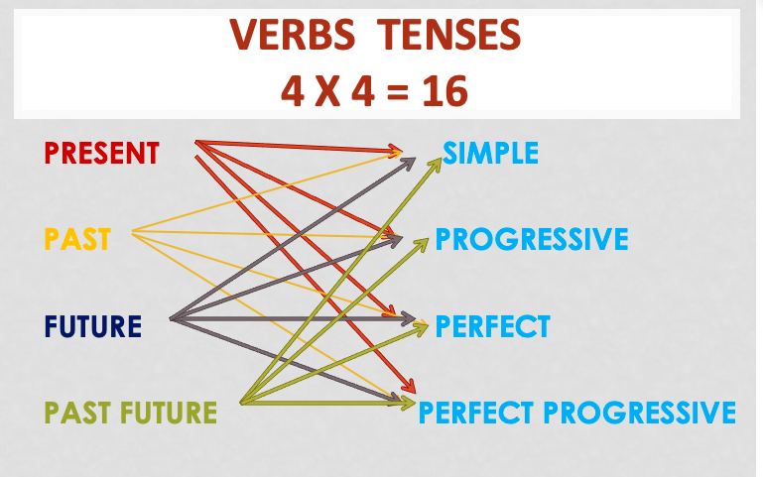

Simple:

Present Simple: I work on Saturdays.
Past Simple: I worked on Saturdays.
Future Simple: I will work on Saturdays.
Past Future Simple: I would work on Saturdays.

