ARC Workshop Notes: Summary and Reflection Yegoryan
October 10, 2020

Academic Papers:
- Summary/Response
- Essay
- Book report (summary of the book plot+ your opinion)
- Research paper
- Observation papers (summary/ factual evidence/explanation)
- Analysis paper (Eng.) 102/103 (Summarize the text + express your opinion using critical thinking)

The Structure of Summary/ Reflection Paragraphs:

Roof sentence: The author’s name/ the title of the work/ the overall main idea

Summary Body: brief retelling of the text with main details, but NO personal
opinion / 5W+H: who, what, when, where, why, how

Reflection Paragraph briefly state your opinion about the text you have read. Evaluate the text by stating your overall opinion about it, about the main idea/ message, the word choice, if is it applicable (can it apply to you or others you know), etc. You may also bring an example to support your response claims.

Consider the image of the Summary House and the 2 Activities:

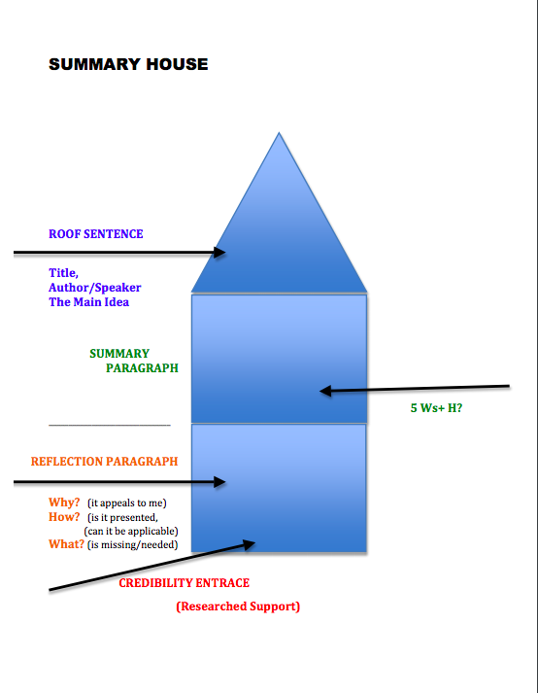

ACTIVITIES:

1. Consider the short story by Stephanie Disney “Seeing with the Heart”
(the story is on this ARC Workshop site under Activity section).
Read it and then summarize and reflect on the text using Summary / Reflection
structure. You may also consider the questions after the text to help you
generate ideas and think of personal example to show how this story can apply to us!

2. Consider the motivational speech by Admiral McRaven “Make your Bed”
https://www.youtube.com/watch?v=DQiX54HqoAU
Watch it and then briefly summarize the content of the video and reflect expressing your
opinion about the video in a paragraph following your summary.

