ARC WORKSHOP Activity Yegoryan

Using the Ted video “The 8 Traits of Success” by Richard StJohn to discuss some possible essay styles

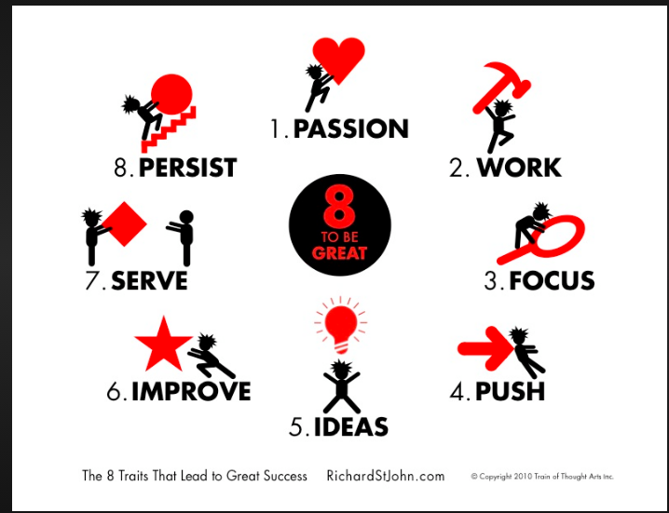

Argumentative/ Persuasive Essay

Narrative Essay

Compare / Contrast

Definition

Descriptive

Analysis

Informative

