MLA: Modern Language Association providing guidelines for:

- Format
- Citation

Formatting
• 12 font Times new Roman, double spaced, 1’ Margins in all sides
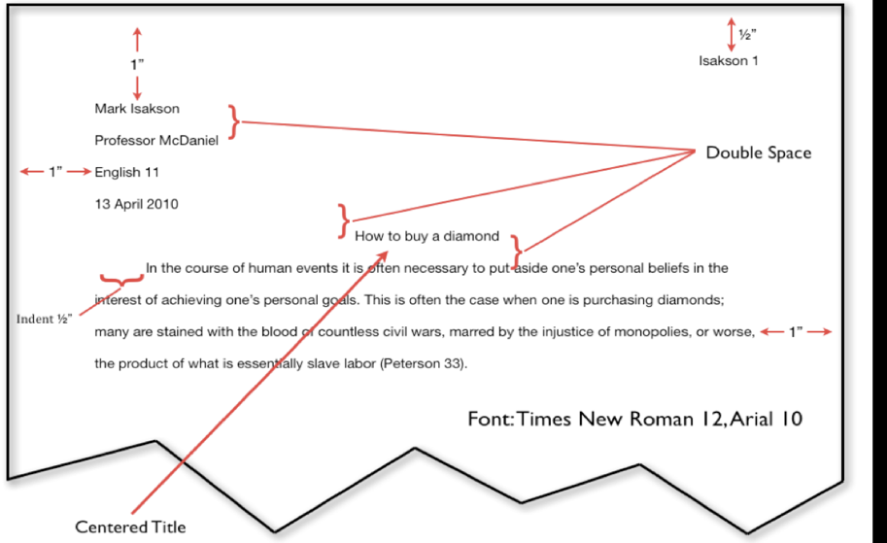
• Header: Your last name and page number
• Heading (only on the 1st page)

Citation:
- In-Text Citation (Quotes)
- Works Cited Page (Sources- places (articles, web sites, books) we got the quotes)

Where to look for Credible Sources?
- LAVC Library database
- Google Scholar
- The credible citations that were used in a (credible) source or in wiki they are in the END of the article or Wikipedia information
__________________________________________

In-Text Citation:

- Direct Quotes - “word by word” direct quote cannot be longer than 4 typed lines
- Indirect Quotes – the idea is from a source restated with your words

**When any change is done in the Direct Quote, (if you may need to add any word(s)), you should use [ ].
If any word/ phrase/ line may be eliminated/ cut off from the original sentence cited in your essay, use […]

How to introduce an In-text Citations:

- By Signal words - According to Tom Smith the author of the article, “………..”
As Tom Smith, the author states “………….”

- Parenthetical - “…………..” (Smith).

Let’s Try:

Let’s consider the following online article:

Title: “Kiwi company trials four-day working week for more 'energised, engaged workforce'”
Author: Sam Clarke, (1News Digital Producer)
Publication Date: July 17, 2018
Source: 1News

https://www.1news.co.nz/2018/07/18/kiwi-company-trials-four-day-working-week-for-more-energised-engaged-workforce/

Direct Quote: Parenthetical Citation

“The dream of a four-day working week is looking more likely after a study found positive benefits for both employers and employees” (Clarke).

Direct Quote: Signal words/ phrases

According to Sam Clarke, the speaker on 1News, “The dream of a four-day working week is looking more likely after a study found positive benefits for both employers and employees.”

------------------------

Indirect Quote: Parenthetical Citation

A study experimenting a four-day working week resulted with positive effects and benefits for both employees and employers (Clarke).

Indirect Quote: Signal words/ phrases

According to Sam Clarke, the speaker on 1News, a study experimenting a four-day working week resulted with positive effects and benefits for both employees and employers

How to present the source in the in-text citation?

What to mention in the parenthesis or with the signal words when citing a direct or paraphrased quote:

- Author’s name (last name)
If no author:
- Title of the source (article). Remember: “Titles of articles, video” BUT. Titles of books, movie
If no Title
- Name of the Website (in italics): the name of the website is not the URL address (it is NOT www…)

Example: Let’s use the same online article with an author and then, cite it as if it doesn’t have author nor title.
https://www.1news.co.nz/2018/07/18/kiwi-company-trials-four-day-working-week-for-more-energised-engaged-workforce/

Article has an Author: Direct and Indirect In-text Citations with Parenthetical and Signal words

“The dream of a four-day working week is looking more likely after a study found positive benefits for both employers and employees” (Clarke).

According to Sam Clarke, the speaker on 1News, “The dream of a four-day working week is looking more likely after a study found positive benefits for both employers and employees.”

Lets’ say the Article doesn’t have an Author, so we will use the Title:

“The dream of a four-day working week is looking more likely after a study found positive benefits for both employers and employees” (“Kiwi company trials”).

As the article “Kiwi company trials” states, “The dream of a four-day working week is looking more likely after a study found positive benefits for both employers and employees.”

Lets’ say the Article doesn’t have an Author and no Title, so we will use the name of the source ( website):

The dream of a four-day working week is looking more likely after a study found positive benefits for both employers and employees” (1News).

As stated in the website 1News, “The dream of a four-day working week is looking more likely after a study found positive benefits for both employers and employees.”

When citing from the sources, REMEMBER again:
• Do not over-quote!
• You can have in-text direct quotes or paraphrased. In both cases, you should validate /
mention the author/ the source
• Use credible sources (valid websites, Google Scholar and School Library Academic Databases)

Works Cited –is the last page of your paper that presents the details of the sources cited in the essay

- is a separate page

- includes the details of the in-text citation sources

- Follows the same MLA Formatting: Times New Roman 12 font and is Double Spaced

- Citations are in ABC order

- The 2nd and any additional line belonging to the same citation will be indented

- Corresponds to the source mentioned in the in-text (whatever information about the sources is stated in the parenthesis or with the signal word when presenting the quote)

That is to say, if the author’s last name is mentioned, then that would be the leading word presenting the details of the source in the Works Cited page. If there is no author, and the title of the article is used with the in-text citation, then that title will start the citation in the Works Cited page.

Works Cited

Clarke, Sam. “Kiwi company trials four-day working week for more 'energised, engaged workforce'”
1News. 17 July 2018. https://www.1news.co.nz/2018/07/18/kiwi-company-trials-four-day-working-week-for-more-energised-engaged-workforce/
Gosselin, Peter G. “Unconstitutional Sections of the Patriot Act.” New York Times, 11 Jan. From
newspaper Last Name, First Name. “Title of Article.” Title of Newspaper. Pub. Date: 2009.

