Question types:

Type 1: Agree or Disagree

- Do you agree or disagree with the following statement? When people solve problems as a group, they come up with better solutions that if they were to try to solve the problem individually. Use specific reasons and examples to support your answer.

- TV, Internet and radio are very popular nowadays, and many people will replace books and written words as the main sources of information. To what degree do you agree or disagree to this position? Use specific reasons and examples to support your answer.
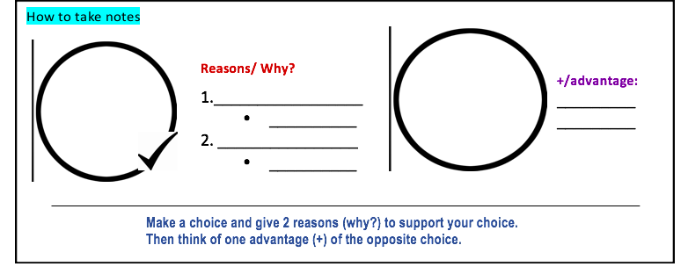

I Agree
with the statement

I Disagree

Type 2: Pick a Stance from Two Options/ State your Preference

- Some people think that the family is the most important influence on young adults. Others think that friends are the most important influence on young adults. Which view do you agree with? Use examples to support your position.

- Some people enjoy change, and they look forward to new experiences. Others like their lives to stay the same, and they do not change their usual habits. Which view do you agree with? Use examples to support your position.

Friends are the most
important influence
on young adults
family is the most
important influence
on young adults

FORMING THE THESIS with the “Macho Although” for a Fully-developed Thesis.

Variations of “Macho Although”
Option 1: Agree/Disagree / Emphasizing Personal Opinion
Although (the opposite choice) many choose (assume that) ________________________________, actually (your choice) I agree (disagree) with the statement. My decision is based on the following reasons.

Option 2: Stating a Preference: Some/Others (argument with Verb)
Although (the opposite choice) verbing _______________________ may (be)_________________, actually (your choice) verbing _________________________ is more preferable because of the following reasons.

Option 2: Stating a Preference: Some/Others (argument with a Noun)
Although (the opposite choice) ________________________, actually (your choice) ________________because of the following reasons.

