Parts of Speech

- Noun
- Verb
- Adjective:
- Adverb (How? When? Where?)
- Pronoun
- Pre-position
- Conjunction
- Interjection

Meaningful Linguistic Units

- Text / essay
- Paragraph
- Sentence: Subject + Predicate (Verb) / complete thought (.)
- Clause When you see Tom…( Dependent Clause)
- Phrases
- Words
- Morpheme (prefix, root, suffix) un-happy, Work-ing

SENTENCE- S+V/ Complete thought.
Members of the Sentence Family

- Subject (simple; complete). My little sister Anna is singing loudly every evening.
- Predicate (Verb)
- Object (Direct; Indirect; Object with Preposition)
- Complement (Subject Complement; Object Complement) Tom seems happy.
- Modifier

My little sister Anna is singing loudly every evening.

Verb - is a part of speech and it is also the predicate in the sentence that shows the action of the subject.

Verbs show action / non-action (be (state of being), emotions, mental activities, senses)

Non-action verbs DO NOT take -ing. Ex. I love him. NOT: I am loving him.

BUT: He is so rude to me; I am hating him right now. / I see you. (sense) - Anna is seeing Tom (dating)-Action verb
***McDonald’s slogan “I’m Loving It !” (I love it- correct grammar)

VERB TYPES
- Main (regular “go” and irregular “went”) I have a sister.
- Auxiliary (helping verbs) Aux + Main Verb. I have seen your sister.

Main Verbs: go, eat, dance, do, drink, be, stand, have, see
Do you do your homework every day? I have had a great day. / I had had a boring day.

Main Verbs: I have a sister. I have seen your sister.

- Transitive: S+V+O. I have….. I see…. I opened…
- Intransitive: S+V. She is crying. The birds fly.
- Linking: be, appear, seem, look, become, grow

The girl is beautiful. He looks tiered.
The girl works every day.

Ex. Tom works hard (adv./modifier) The job seems hard (adj./. subject complement)

Auxiliary (helping verbs) Aux + Main Verb
- Modal verbs: can, could, may, must, should, will/ would, have to, should
- Primary verbs: do (does, did), be (am, is, are, was, were), have (has, had), will (would)

Primary Auxiliaries are used with the Main Verb to form VERB TENSES

4 Timing 4 Categories
Present | Simple do (does, did), (In question/ negative)
Past | Progressive be (am, is, are, was, were) + Verb + ing
Future will+ Verb | Perfect have (has, had) + Verb + ed
*Past Future would+ Verb | Perfect Progressive have been + Verb + ing

*Yesterday morning, I told my mom that I would meet Tom for dinner.

16 Verb Tenses:

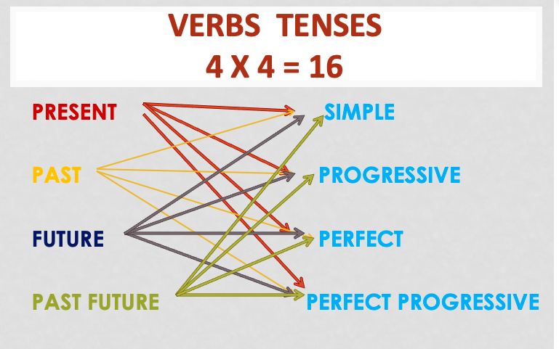

VERB TENSES WITH Tense CATEORIES

Simple: main verb

Present Simple: I work on Saturdays.
Past Simple: I worked on Saturdays.
Future Simple: I will work on Saturdays.
Past Future Simple: I would work on Saturdays.

PROGRESSIVE: Be (am, is, are, was, were) + main v + ing

Present Progressive: I am working on Saturdays.
Past Progressive: I was working on Saturdays.
Future Progressive : I will be working on Saturdays.
Past Future Progressive: I would be working on Saturdays.

PERFECT: have (has/had) + main v +ed

Present Perfect: I have worked on Saturdays.
Past Perfect: I had worked on Saturdays.
Future Perfect: I will have worked on Saturdays.
Past Future Perfect: I would have worked on Saturdays.

PERFECT PROGRESSIVE: have been + Verb + ing

Present Perfect Progressive: I have been working on Saturdays.
Past Perfect Progressive: I had been working on Saturdays.
Future Perfect Progressive: I will have been working on Saturdays.
Past Future Perfect Progressive: I would have been working on Saturdays.
_________________________________

