GRAMMAR
Subject, verb, noun, adverb
Tom is my brother.

PARTS OF SPEECH
8 parts of speech
- Noun (person, place, thing, idea)
- Verb (action/ non-action): MAIN and AUXILIARY (Helping Verbs)
- Adjective ( describes noun, adjective)
Article (a (an), the)
Numerals (1, 2, 3- first, 2nd,- 2/4) Nominal/ Cardinal/Fraction
Demonstratives (this, that, these, those)
- Adverb (describes verb, adjective, adverb)
- Preposition (on , under, by, next to): (Size of the place: in LA, at LAVC)
- Pronoun ( she, her, hers, )
- Conjunction (coordinating, subordinating, transitional, correlated)
- Interjection (oh! well! Wow! OMG!) Wow, you are here!

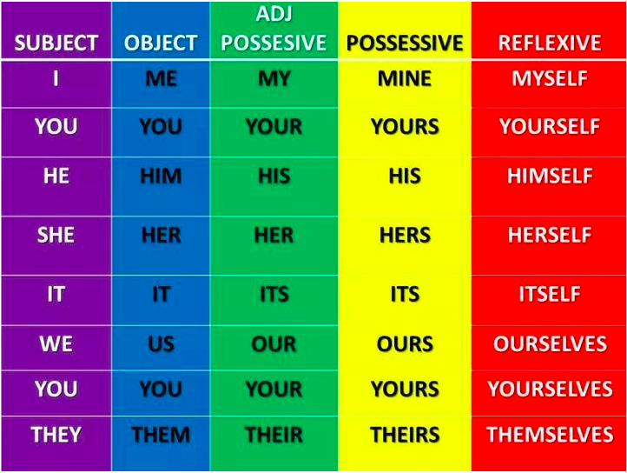
PRONOUN TYPES:

MEANINGFUL LINGUISTIC UNITS

- Morpheme (prefix, root, suffix) un-happi-ly
- Words (happy, girl)
- Phrase
- Clause (dependent, independent)
- Sentences
- Paragraph
- Text/ Essay

Adjective: Word (beautiful)
Phrase ( a beautiful flower)
Clause ( the woman, who is very beautiful, is our CEO)

S+V union Complete Thought
Phrase | No | NO
Clause | Yes | YES ( Independent) / NO ( Dependent)
 |  | Example: When I came home late….
Sentence | Yes | YES (Always)

SENTENCE: subject + verb, a complete thought (.)

MEMBERS OF SENTENCES and Parts of Speech (PS) used for them
- Subject (simple/ complete) PS: Noun, Pronoun, Gerund (smoking is bad)
- Predicate (verb) (simple/ complete) PS: verb
- Object (direct/ indirect/ with preposition) PS: noun, pronoun
- Complement (subject/ object) PS: Adjectives
- Modifier ( of time, place, kind) PS: Adverbs, adjectives

Analyzing as a sentence:
Complete subject Complete predicate
My little sister Anna sings happily every day.
Anna: simple subject / sings: simple predicate ( verb)

Analyzing as parts of speech:
My little sister Anna sings happily every day.
3 Adjectives Noun Verb adverb adverb

ADJECTIVES vs ADVERBS

Adjectives describe Noun, Adjective
Ex. beautiful girl
Adj noun

blue denim pants blue and denim pants a small, round, kitchen table (N)
adj. adj. Noun adj. adj. noun adjs
___________________________________________
Adverbs describe Verbs, adjectives, adverbs

Ex. walk slowly very beautiful girl I love my husband very much
verb adverb adv. Adj. noun verb adv adv

PLACING IN THE SENTENCE
Adjectives are used before the noun (subj) / unless it is a “drunk” adjective
Adverbs are used after the verb (predicate) but can also be wherever they want

My sister Anna will meet Tom tomorrow.
Tomorrow, my sister Anna will meet Tom.

“drunk” adjective
Anna look tiered.
V adj

The hard work pays well. (hard: adj.)
Tom works hard. (hard: adv.)
The work seems hard. (hard: adj.)

Remember:
ADVERBS: how? when? where?
Tom sings happily.
I love him very much
I will meet him tomorrow.

ADJECTIVES are expressed with the following Parts of Speech

- Article ( the boy)
- Numeral ( five boys)
- Demonstratives (that boy)
- Noun (kitchen table, baby boy)
- Possessive Pronoun (my book/ the book is mine)
- Verb form: Participle (verb+ing / verb+ed)
The smoking boy is my classmate.
The finished work was submitted.
__________________________________________________________________

