MLA:
- Format
- Citation

Formatting
• 12 font Times new Roman, double spaced, 1’ Margins in all sides
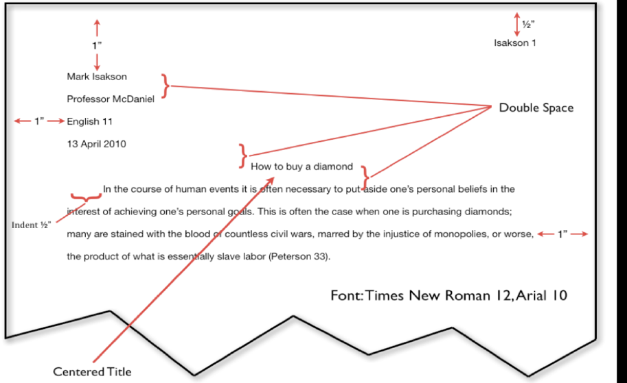
• Header: Your last name and page number
• Heading (only on the 1st page)

Citation:
- In-Text Citation (Quotes)
- Works Cited Page (Sources- places (articles, web sites, books) we got the quotes)

Where to look for Credible Sources?
- LAVC Library database
- Google Scholar
- The credible citations that were used in a (credible) source or in wiki they are in the END of the article or Wikipedia information
__________________________________________

In-Text Citation:

- Direct Quotes - “word by word” direct quote cannot be longer than 4 typed lines
- Indirect Quotes – the idea is from a source restated with your words

Introducing In-text Citations:

- By Signal words - According to Tom Smith the author of the article, “………..”
As Tom Smith, the author states “………….”

- Parenthetical - “…………..” (Smith).

EXAMPLES

Direct Quote: Parenthetical Citation

“The dream of a four-day working week is looking more likely after a study found positive benefits for both employers and employees” (Clarke).

Direct Quote: Signal words/ phrases

According to Sam Clarke, the speaker on 1News, “The dream of a four-day working week is looking more likely after a study found positive benefits for both employers and employees.”

------------------------

Indirect Quote: Parenthetical Citation

A study experimenting a four-day working week resulted with positive effects and benefits for both employees and employers (Clarke).

Indirect Quote: Signal words/ phrases

According to Sam Clarke, the speaker on 1News, a study experimenting a four-day working week resulted with positive effects and benefits for both employees and employers

What to mention from a source in the in-text citation:
Author’s name (last name)
If no author:
Title of the source (article). Remember: “Titles of articles, video” BUT. Titles of books, movie
If no Title
Name of the Website

Example: Let’s use a website article with an author and then, cite it as if it doesn’t have author nor title.
https://www.1news.co.nz/2018/07/18/kiwi-company-trials-four-day-working-week-for-more-energised-engaged-workforce/

Article has an Author: Direct and Indirect In-text Citations with Parenthetical and Signal words

“The dream of a four-day working week is looking more likely after a study found positive benefits for both employers and employees” (Clarke).

According to Sam Clarke, the speaker on 1News, “The dream of a four-day working week is looking more likely after a study found positive benefits for both employers and employees.”

Lets’ say the Article doesn’t have an Author, so we will use the Title:

“The dream of a four-day working week is looking more likely after a study found positive benefits for both employers and employees” (“Kiwi company trials”).

As the article “Kiwi company trials” states, “The dream of a four-day working week is looking more likely after a study found positive benefits for both employers and employees.”

Lets’ say the Article doesn’t have an Author and no Title, so we will use the name of the source ( website):

The dream of a four-day working week is looking more likely after a study found positive benefits for both employers and employees” (1News).

As stated in the website 1News, “The dream of a four-day working week is looking more likely after a study found positive benefits for both employers and employees.”

When citing from the sources, REMEMBER again:
• Do not over-quote!
• You can have in-text direct quotes or paraphrased. In both cases, you should validate /
mention the author/ the source
• Use credible sources (valid websites, Google Scholar and School Library Academic Databases)

Works Cited – is a separate page (last page of your paper and it follows the same MLA Formatting )
So, it has Times New Roman 12 font and is Double Spaced
Citations are in ABC order

Works Cited

Clarke, Sam. “Kiwi company trials four-day working week for more 'energised, engaged workforce'”
1News. 17 July 2018. https://www.1news.co.nz/2018/07/18/kiwi-company-trials-four-day-working-week-for-more-energised-engaged-workforce/
Gosselin, Peter G. “Unconstitutional Sections of the Patriot Act.” New York Times, 11 Jan. From
newspaper Last Name, First Name. “Title of Article.” Title of Newspaper. Pub. Date: 2009.

